Scrum - Rituals Workbook

Iterative Time-box Activities

|  |
| --- |
| Analyze |
| Design |
| Construct |
| Integrate |
| Test |

Quality of an Iteration

|  |
| --- |
| Iteration 1..2..3…() |

Quality of Outcome Determination

|  |
| --- |
| Increment (Product) |

|  |
| --- |
| Sprint definition  Heart of scrum , one month or less, time box for creating an increment, and the team determines the length based upon their belief of what would work best to enhance team productivity. |

|  |
| --- |
| Determination of length of sprint.  2-4 weeks short and consistent duration, goal should not be altered after sprint begins. Attempts to reach the end of state specified by Definition of Done. Recurring timeframe could be changed only for a very good reason. |

Sprint Rituals

|  |  |
| --- | --- |
| * Sprint Planning Meeting * Daily Stand ups * Development work * Sprint Review * Sprint Retrospective | * Beginning of every sprint * Designated time every day * Team members perform work day to move sprint forward towards achieving the sprint goal * Schedules meeting where the completed increment is demonstrated to stakeholders and feedback about increment viability is received by the team * Final meeting of a sprint where team evaluate how well they performed as a team in this point. The goal of this meeting is to look for ways that the team can improve their productivity and increase their velocity. |
| Estimation | Act of determining the size of something  In scrum estimating helps set expectations as to amount of work that can be performed or the length of time until something is finished. |

3 types of estimation When this occurs Unit of measure

|  |  |  |
| --- | --- | --- |
| Relative Estimates | Consensus | Precision |
| Portfolio Backlog | Product Backlog | Sprint backlog |
|  |  |  |

Scrum Roles Involved in Estimation

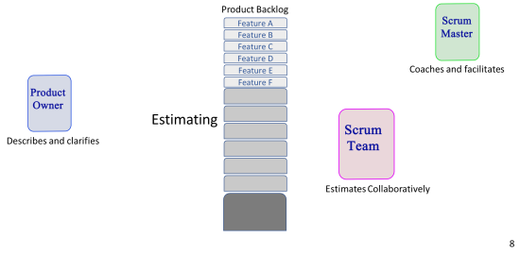Planning Poker Triangulation

|  |
| --- |
| Ideal day / Ideal hour  focus on task; no interruptions.   Constantly able to focus; No interruptions. |
| Problems with Ideal estimation  There is not a clear agreement on amount of work involved, then high and low bidders will explain why they chose that bid. |

Daily Standup

|  |
| --- |
| Purpose   to gather information and plan time and conflict resolve from previous meeting |
| 3 Questions  What did you do since last meeting ?  What are you planning to do before the next meeting?  Do you experience any obstacles? |
| Rules   Adapt the plan for the next 24 hours to ensure that we move forward toward a successful increment. |

Pair Programming

|  |
| --- |
| * Collective Code Ownership * All team members understand the code * Two team members; one task. * Driver and navigator * Constant Reflection * Reduction of noise |

Sprint Review Meeting

|  |
| --- |
| * Informal; no PowerPoints * Demo meeting * 4 hours max * Elicit feedback * Foster collaboration * Story of the journey |
| Participants   Scrum team, product owner, scrum master |
| Timing  4 hours |
| Location  coffee shop, zoom meeting. Next to scrum objectives |
| Expected Outcomes   Recognize sprint options and have a fleshed outcome of the daily sprint |

Sprint Retrospective Meeting

|  |
| --- |
| Last activity of sprint |
| 3 hours max |
| Reflect on sprint |
| Improvements of process for future |
| Review definition of done |

Ritual Timing

|  |  |
| --- | --- |
| Sprint Duration | 1 month |
| Daily Stand-up | 15 minutes |
| Spring Planning | 8 hours |
| Spring Review | 4 hours |
| Sprint Retrospective | 3 hours |

